A Project Report On

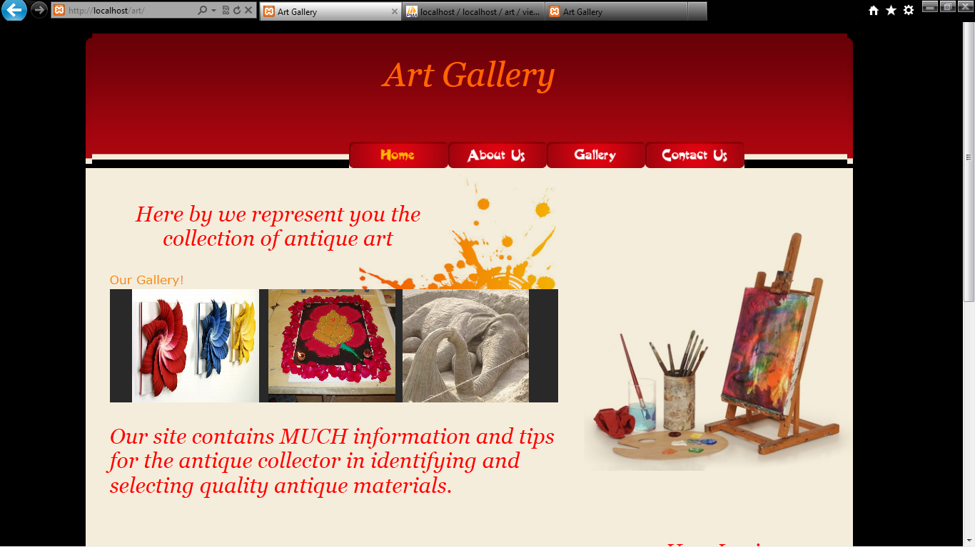

As partial fulfillment of Bachelor Of
Computer Application
[BCA – 5TH]

: Submitted To:

Matushri Virbaima Mahila College Of
Comm., Management & I.T.

: Affiliated To:

Saurashtra University, Rajkot

Guided By:
Tulsi Dalsania
[MVM College, Rajkot]

Prepared By:
Dhol Avani [26]
Hinsu Pooja[35]

